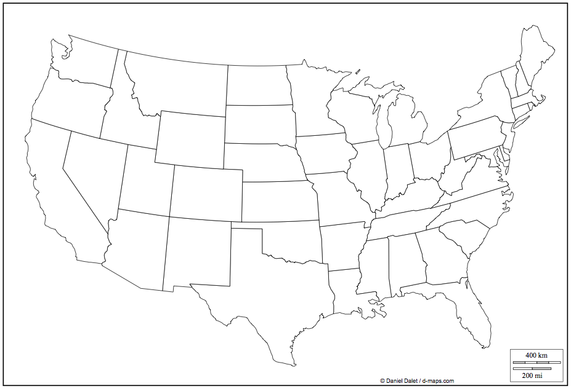

Name _____________________________________________________________________________________________ Per _________

**United States Map**

Label all 50 states and the cities of San Diego, New York, Boston, and Washington, D.C.