History Focused Notes

Essential Question
- Follow the instructions on the opening page for the chapter in your Inquiry Journal.
- Write 3 questions you might need to answer to be able to answer the EQ for this chapter.
  - Do not use the examples provided in the Inquiry Journal.

Engage With The Text Lesson Notes (DAY 1)
- Go to the “Engage With the Text” page for the chapter and lesson you are working on.
- Read the questions and look over the graphic organizers so you know what to look for as you work through the lesson.
- Read through the text for this lesson and answer the questions as you go.
  - Your answers must be in complete sentences, except in charts/tables.
- When you find a key term/vocabulary word in the text, write it down in the blue “My Notes” section on the left side.

Revisiting/Annotating Notes (DAY 2)
- Put any needed finishing touches on your answers.
- Annotate your notes:
  - Take notes/write questions in the margins.
  - Circle any key terms you see in your answers.
  - Highlight or underline important concepts and ideas
  - ! - next to things you think may be on a test
  - ? - next to things you have questions about or want to clarify
  - Use as many different colors as possible.
- Be prepared to share your answers.

Guiding Questions (DAY 3)
- In the textbook find at least two Guiding Questions for this lesson.
- Answer these questions in complete sentences in your Inquiry Journal.
  - You do not need to write the questions IF you restate the question in your answer. It needs to be obvious what the question was.
- Be prepared to share your answers.

EQ Summary (When finished with the entire chapter)
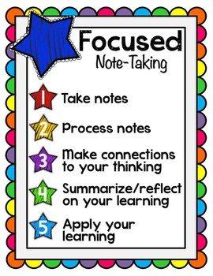
- Go to the “Report Your Findings” page at the end of the chapter in your Inquiry Journal.
- Answer the questions/fill out the tables.
- Complete the “Connect to the Essential Question” portion at the end.
  - Use the space provided to write an EQ summary paragraph.
    - It does not need to be an essay, but you do need to RACE your answer.
  - Your summary must fully address the question. Use your notes and primary sources for evidence.

